We are going to build an educational program about the Great Pyramid. We are going to give the user a choice of a few pieces of information to view. The different information is as follows:
- It has been estimated that the Great Pyramid weighs around 5.9 million tons. It is also said that the pyramids only took 20 years to build. Calculate the weight of stone moved each day in order to complete this in 20 years. Remember, these people supposedly hadn’t discovered the wheel when they did this….
Display the result.

- Each side of the Great Pyramid is 230.4 meters. Its height is 146.5m (originally… this has changed somewhat over time)
Calculate the perimeter of the Great Pyramid. Now divide the perimeter by its height.
Display the result. Do you see a significance to this number?

Perimeter = 230.4 * 4

- Calculate the circumference of a circle that encloses the outside of the Great Pyramid and the circumference of a circle that fills the inside.
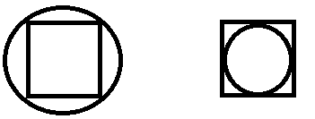
Circle 1 Circle 2
Once you have calculated the two circumferences, subtract the smallest one from the biggest one.
Display the result. Do you see significance to this number? (Hint: This number is a reduced version of a famous number. You will have to multiply this number by some factor of 10.)

Your program should ask the user which piece of information to view. It should then display the appropriate output for that choice. Your program should then loop back to the beginning and ask for another choice. Remember to give them a way to quit the program (i.e. exit the loop).

